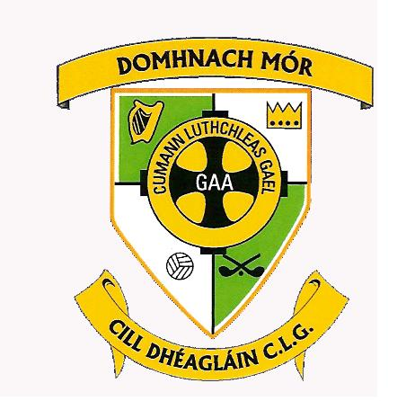
Donaghmore Ashbourne GAA
Killegland West
Ashbourne
Co Meath
Ph: 01 8499140
Email: donashadmin@eircom.net
www.donashgaa.com

Outgoing Executive Committee 2019

Chairperson: Michael McGill

Vice-Chairperson: Brian Thomas

Secretary: Deirdre Keaveney

Head of Finance: Paul Walton

Head of Games: Tony Wall

Registrar: Sarah McEvoy

P.R.O.: Chad Slattery

Players’ Representative: Martin Lynch

Executive Officers:

Sile Ní Dhuibhne
John Harmon
Marie McGonigle
Noel Martyn

