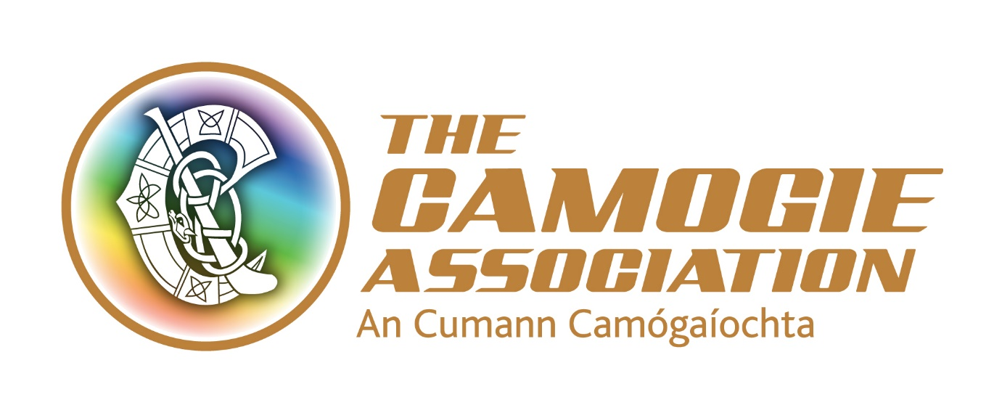
Vacancy
Participation and Growth Officer for Meath/Kildare
The Camogie Association is recruiting a Participation and Growth Officer for a new three year project in Meath and Kildare. The successful candidate will work across both counties as part of an overall plan to increase and grow Camogie participation.
The Officer will work in accordance with the priorities of the Camogie Association’s National Development Plan Our Sport Our Future and an agreed annual work programme.
A Steering Group drawn from Meath and Kildare Camogie and related personnel will support the work. The post will be line managed from within the Camogie Association staff.
A full job description and application form is downloadable from http://www.camogie.ie/careers.asp

The closing date for applications is August 30th 2016. Interviews are scheduled for 14/15th September 2016.

Duties and Responsibilities
- To review existing Camogie structures in Meath and Kildare to establish the current position of the sport and the potential for sustainable participation and growth across both counties
- Identify opportunities and plans to develop a targeted growth plan and strengthen the infrastructure to meet the needs of Camogie growth and participation, based on changing demographics and long term sustainability
- Introduce Camogie development initiatives and projects appropriate to clubs and the education sector with a focus on the following:
  - Teenagers across both counties
  - Former players across both counties
  - New and/or existing areas of urban/suburban development in both counties
- Build capacity of coaches, administrators and referees in Camogie to support sustainable long term camogie structures
- Liaise and network with a range of stakeholders, including but not limited to county boards, clubs, mentors, parents, local sport partnerships, local community groups and the education sector to identify potential projects, and support them in the wider provision of Camogie
- Provide information on the activities and plans regarding Camogie Growth and Participation to various stakeholders, Camogie fraternity and the general public.
- Work with Camogie volunteers to enhance the profile and position of Camogie in the designated areas
- To work with and report regularly to the Meath and Kildare Project Steering Group

Person Specification
Essential Criteria

- At least 4 years’ experience (paid or voluntary) of working in a development role in sport, community development, youth work or other relevant area
- An appropriate third level education qualification
- Extensive experience of project management
- Experience of using empowerment strategies and practice including consultative methods, group work and facilitation
- Experience of working with volunteers, children and young people
- Proven ability to network
- Dynamic self-starter with a proven ability to work independently
- Exceptional interpersonal skills, proven ability to work and develop relationships to achieve targets
- A high level of proven organisational ability and administrative and IT Skills
- Excellent communication/presentation skills (verbal and written)
The post holder will be required to have a clean full driving licence and the appointment will be subject to Garda/PSNI vetting clearance.

Desirable criteria
- Knowledge of coach education structures in Gaelic Games, particularly Camogie
- Experience of involvement in hurling/camogie
- Familiarity with interpreting research data
- Ability to converse in Irish (in context of working with Gaelscoileanna)

Terms and conditions
The post will be based in the Camogie Association’s national office in Dublin and/or Sports HQ, Abbotstown, Co. Dublin.

The appointment will be on a fixed term contract basis of 3 years.

The Participation and Growth Officer will be required to work unsocial hours including weekends. From time to time travel will also be required.

The successful applicant must have a clean driving licence; her/his own transport and will be required to comply with Garda/PSNI vetting clearance in advance of taking up the position.

Salary is negotiable, dependent on knowledge and experience. The appointment will be attached to a salary scale ranging from €31,400- €36,700.

Expenses such as travel, overnight accommodation where required and other allowable expenditure will also be paid.

Other terms and conditions include:
7% pension contribution from the Association and subject to employee contribution
Annual leave entitlement of 23 days per annum. In addition, there is additional annual paid leave in the period Christmas Eve/New Year
A time in lieu facility (TOIL) for work in excess of weekly contracted hours
Study leave
Travel (bike to work scheme/tax saver commuter tickets)

