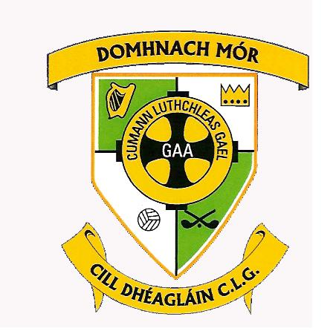
Donaghmore Ashbourne GAA
Killegland West
Ashbourne
Co Meath
Ph: 01 8499140
Fax: 01 8499144
Email: donashadmin@eircom.net
Web: www.donashgaa.com

A chara
I wish to inform you that the Annual General Meeting of Donaghmore Ashbourne GAA Club will take place in the clubhouse on Wednesday 7th December at 8pm.

You are hereby invited to nominate registered club members for election to the Executive Committee for the coming year and submit motions for consideration at the Annual General Meeting. Such nominations and motions must be returned to the Secretary on or before 6pm on 6th November 2015

In relation to nominations for election to the Executive Committee please ensure that the nominated registered club member has been approached and has agreed to accept the nomination. Note that to be eligible for elective office club members are required to be registered as members of the Association on or before 31st March 2016.

I enclose for your information, nomination paper, motion paper and a list of the members of the outgoing Executive Committee.

Is mise le meas

Deirdre Nic Giolla Earna
Rúnaí

3rd November 2016

